Shoulder Arthroscopy Instructions

What is a shoulder arthroscopy?
A shoulder arthroscopy is a minimally invasive surgical procedure, which provides the physician with a clear interior view of the shoulder joint. This can help with the diagnosis and treatment of disorders of the shoulder. The procedure is performed by placing an instrument, known as an arthroscope, into the shoulder joint through two or three small ¼ inch incisions.

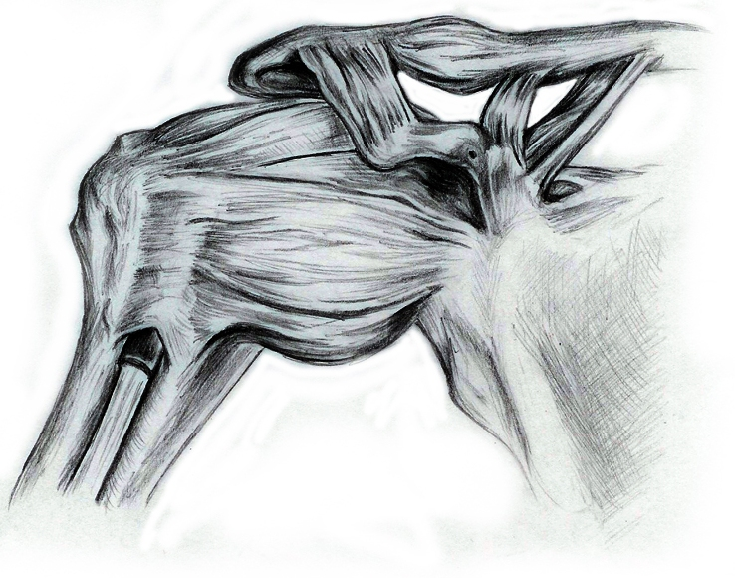
By NM

Anesthesia:
Based on your physical health history you have had either general anesthesia or an anesthetic block for this procedure. If s/he recommended general anesthesia it is advised that you rest for the remainder of the day. Anesthetic agents can remain in one’s body for up to 24 hours. As a result you should not operate heavy machinery, drive a motor vehicle, consume alcohol, or make any important business decisions for 24 hours. If you had a regional anesthetic block please refer to the informational handout provided to you.

Pain:
You will be given a prescription for pain medicine either in your physician’s office prior to the surgery or before you are discharged home from the hospital. Take this medication as directed. It is not unusual to have a fair amount of pain and some drainage from the incisions during the first 48 hours post-op. To help relieve swelling and pain, use ice over the top of the shoulder for the first 24 to 48 hours. Ice should be used during the day for 20 minutes on 20 minutes off.

Dressing:
If an anesthetic block is given it is most likely that you will be sent home with a sling. You should keep the sling on until you get full sensation back in your arm. You may take the bandages off two days after surgery. If steri-strips were applied to the incisions, do not remove, let them fall off by themselves. Remaining steri-strips may be removed after day 14 following your surgery. However, if you don’t see anything on the incision, cover them with gauze pads or band-aids until the incisions stop draining.
Bathing:
You may shower two days after your surgery. DO NOT scrub the wounds in the shower; simply allow water to rinse over the incisions. After your shower pat the incisions clean and dry. Then apply dressing (see above Dressing).

Driving:
You may resume driving in three to four days or as tolerated. With a rotator cuff repair this is often times longer. However, you should also no longer require pain medication before resuming driving.

Notify your doctor if any of the following occurs:

- You have persistent drainage saturating dressing
- You have redness of the incisions with pus like drainage
- You have a fever greater than 101 degrees.
- You have severe pain not relieved with your pain medication prescription

