Septoplasty Instructions

What is a Septoplasty?
A septoplasty is a surgical procedure to correct a deviated (or crooked) septum. The nasal septum is the separating wall between the two nostrils. This is made up of cartilage and bone. A septoplasty is recommended to fix a deformed septum or to correct irregular air flow often times caused by a deviated septum. A deviated septum can make it difficult to breathe through your nose and can contribute to sinus infections.
Nose tip

Septum
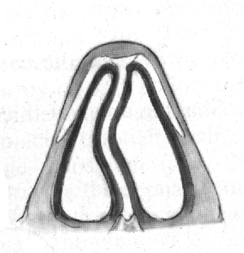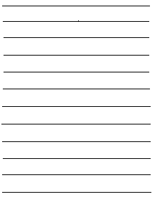
ByNM
General Anesthesia:
You may feel somewhat dizzy or sleepy even after surgery. For the remainder of the day try to rest as much as possible. Anesthetics agents can remain in one’s body for up to 24 hours. As a result you should not operate heavy machinery, drive a motor vehicle, consume alcohol, or make any important business decisions.

Postoperative care:
Do not blow your nose or attempt to clean it for the first week. After five days you may blow your nose and sniff in very gently. If you have to sneeze, do so with your mouth open. You may lubricate the inside of the nostrils by very gently applying Bacitracin ointment with a Q-tip.

Pain:
Be sure to avoid all products containing aspirin for two weeks post surgery. Your physician may prescribe pain medication for you. However Tylenol is a good recommendation for pain and discomfort. It is normal to have sinus pain or pressure until packing and/or splints are removed.

Dressing:
When the surgery is completed the doctor may often times place a small dressing under the nose. This acts as a drip pad to absorb excess drainage that occurs after surgery. You can replace the dressing as needed if staining appears on it. The dressing can be discontinued once drainage has stopped. Excessive bleeding (when the drip pad requires several changes due to bloody saturation over the course of an hour) should be reported to your doctor. It is not unusual to have blood tinge tears following this surgery due to the eye orbits located so close to the nose. This may occur for up to 48 hours after surgery due to the swelling.

Activity:
Do not bend over or perform aerobic activities for at least a week. Exercise raises your pulse and blood pressure, which could may result in increase blood flow to the nose and lead to increase drainage. Your head should be elevated with extra pillows (a reclining chair may be used) for one week after discharge home. If your nose was broken you may notice bruising and swelling around the eyes at first, to help decrease these side effects ice constantly for the first 24 hours and as often as you can after that.

Eating/ Drinking:
Resume your diet as tolerated. Drink plenty of fluids to stay hydrated. For the first 48 hours, beverages are recommended to be cool or lukewarm, NOT HOT!

Notify your doctor if any of the following occurs:
- You have a excessive amount of bleeding from the nose
- You have a fever greater than 101 degrees
- You have severe pain that is not relieved by your pain medication prescription

