Open Carpal Tunnel Release Instructions

What is a Carpal Tunnel Release?
The purpose of a carpal tunnel release is to relieve pressure on the median nerve by cutting the carpal ligament in your wrist. The incision is closed with the expectation that the ligament tissue will scar back together after several months leaving more space.

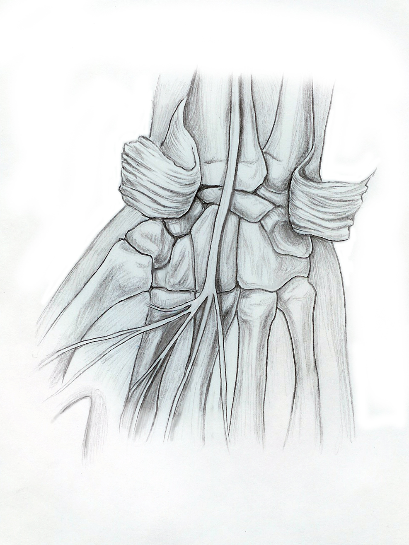
By NM
Anesthesia:
Based on your physical health history your doctor and anesthesiologist will have recommended either general anesthesia or an anesthetic block for this procedure. If s/he recommended general anesthesia it is advised that you rest for the remainder of the day. Anesthetic agents can remain in one’s body for up to 24 hours. As a result you should not operate heavy machinery, drive a motor vehicle, consume alcohol, or make any important business decisions for 24 hours. If you had a regional anesthetic block please refer to the informational handout provided to you.

Pain Control:
You will be given a prescription for pain medication either in your doctor’s office prior to the surgery or before you are discharged home from the hospital. Take your medication as directed. Note any reactions to your medication to your doctor like itching, swollen lips or skin. This could be an allergic reaction to the medication. Keep your hand elevated above the level of your heart (on a pillow) as much as possible over the next 48 hours. This will help decrease pain and swelling.

Dressing:
Leave your bandage/splint/cast on until you see your doctor. Follow the bathing instructions below. If you notice that your bandage has a moderate amount of staining and or drainage call your doctor. Notify your doctor if you have any problems with your cast/splint.

Bathing:
You may shower as long as you keep your bandage/splint/cast dry. This can be done by placing a watertight bag above the level of your elbow and hold it in place with rubber bands.

Activity:
If you were given an anesthetic block just before surgery, be careful trying to move your hand until the block wears off completely and you have full control of your arm and hand. If your arm is in a sling keep the sling on until normal sensation returns to your arm and hand, this includes sleeping in it the first night.
You may resume most normal activities but avoid vigorous exercises, lifting or straining until seen in the office. Work at fully straightening and bending your fingers for at least five minutes every hour.

Notify your doctor if any of the following occurs:
- Your fingers turn white or dark blue
- Your fingers become cold
- Your fingers lose their feeling aside from the local anesthetic
- You have severe pain in your hand and/or fingers that is not relieved with pain medication
- You have an increase in redness, warmth or drainage from your incision
- You have a fever greater than 101.

