ACL Reconstruction Instructions

What is an ACL reconstruction?
An ACL reconstruction surgery is performed when the Anterior Cruciate Ligament, which is the ligament that connects your tibia (shin bone) to your femur (thigh bone), is ruptured or torn. Because your ACL can’t fully repair itself, your doctor will most likely replace the ligament. This procedure is usually performed through an arthroscope. The new ligament is inserted into the tibia, through the knee joint and out the femur. The ligament is held in place by an internal device in the tibia and femur.

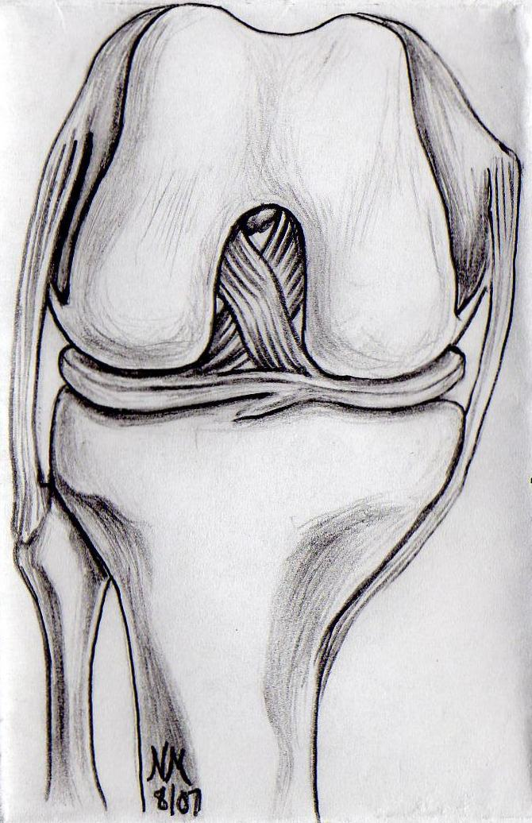

Anesthesia:
Based on your physical health history your doctor and anesthesiologist will have recommended either general anesthesia or an anesthetic block for this procedure. If s/he recommended general anesthesia it is advised that you rest for the remainder of the day. Anesthetic agents can remain in one’s body for up to 24 hours. As a result you should not operate heavy machinery, drive a motor vehicle, consume alcohol, or make any important business decisions for 24 hours. If you had a regional anesthetic block please refer to the informational handout provided to you.

Pain:
You will be given a prescription for pain medication either in your doctor’s office prior to the surgery or before you are discharged home from the hospital. Take this medication as directed. Upon being discharged from the hospital you will most likely be given a cooling unit for your knee. This should be used as follows: two hours on, 30 minutes off. It is recommended that you continue to ice for as long as you have pain and/or swelling.

Dressing:
A soft bandage has been placed on your knee. You may take the bandages off two to four days after surgery. If steri-strips were applied to the incisions, do not remove, let them fall off on their own. Remaining steri-strips may be removed after day 10 following your surgery.
However, if you don’t see anything on the incision, use band-aids to cover your incision for the next few days.

Bathing:
You may shower after four days. DO NOT soak in the tub or scrub the wounds in the shower. Pat the incisions clean and dry, then apply band-aids.

Crutch walking:
Weight bear as tolerated with the assistance of crutches. It is recommended that you walk with crutches until told otherwise by your doctor.

Driving:
You should have stopped taking your prescription pain medication before driving. If you’re right leg was operated on: You shouldn’t drive until you have good control and strength of your right leg which includes being off crutches and the ability to walk without a limp. If you’re left leg was operated on: You may resume driving when you are completely off all narcotic pain medications

Notify your doctor if any of the following occurs:
- You have moderate amounts of persistent drainage saturating the dressing
- You have redness of the incision with pus like drainage
- You have a fever greater than 101 degrees
- You have severe pain not relieved with pain medication

